Experiment Number : 02 Date:

Input and Output Statements in Java
Aim:
To understand and use input and output statements in Java using the Scanner class.
PRE LAB EXERCISE
QUESTIONS
What is input in a program?
Input is the data given to a program by the user or another source.
What is output in a program?
Output is the result produced by a program after processing the input.
Which class is used to read input from the user in Java?
The Scanner class is used to read input from the user.

IN LAB EXERCISE
Objective:
To read input from the user and display the output using Java input and output statements.
INPUT STATEMENT:
SCANNER CLASS
- The Scanner class in Java is used to read input from the user through the keyboard.
It is available in the package java.util.
- The Scanner object reads different types of input such as integer, float, double, and string and stores them in variables.
- To use the Scanner class, it must be imported before using it in the program.
SYNTAX:
- Scanner sc = new Scanner(System.in);
Commonly Used Scanner Methods:
- nextInt() – reads an integer value
- nextFloat() – reads a float value
- nextDouble() – reads a double value
- next() – reads a single word
- nextLine() – reads a complete line of text

PROGRAMS:
Program 1: Read and Display Name
Source Code:
import java.util.Scanner;
class ReadName {
public static void main(String[] args) {
Scanner sc = new Scanner(System.in);
System.out.print("Enter your name: ");
String name = sc.nextLine();
System.out.println("Your name is: " + name);
}
}
Output:
Enter your name: Anitha
Your name is: Anitha
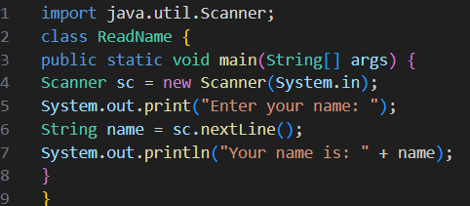
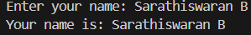
Program 2: Read Two Numbers and Print Sum
Source Code:
import java.util.Scanner;
class SumInput {
public static void main(String[] args) {
Scanner sc = new Scanner(System.in);
System.out.print("Enter first number: ");
int a = sc.nextInt();
System.out.print("Enter second number: ");
int b = sc.nextInt();
int sum = a + b;
System.out.println("Sum = " + sum);
}
}
Output:
Enter first number: 5
Enter second number: 3
Sum = 8
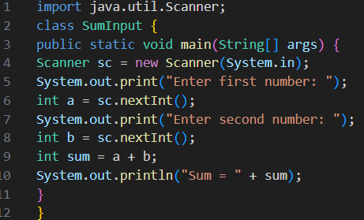
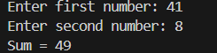

Program 3: Read Length and Breadth and Find Area of Rectangle
Source Code:
import java.util.Scanner;

class AreaRectangleInput {
public static void main(String[] args) {
Scanner sc = new Scanner(System.in);
System.out.print("Enter length: ");
int length = sc.nextInt();
System.out.print("Enter breadth: ");
int breadth = sc.nextInt();
int area = length * breadth;
System.out.println("Area of Rectangle = " + area);
}
}
Output:
Enter length: 10
Enter breadth: 5
Area of Rectangle = 50

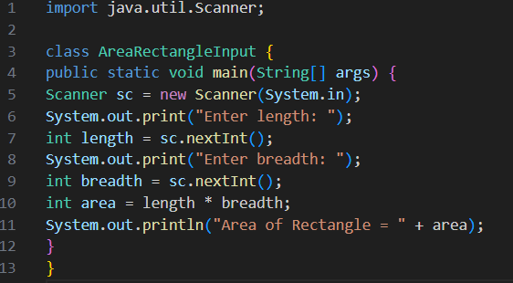
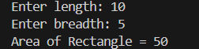

POST LAB EXERCISE
- What is the use of the Scanner class in Java?
  - Scanner is used to read user input like integers, decimals, and strings from the keyboard.
- Which package contains the Scanner class?
  - java.util package.
- What does System.in represent?
  - System.in represents the standard input stream (keyboard input).
- What does System.out represent?
  - System.out represents the standard output stream (monitor/screen output).
- Name any two methods used to read input using Scanner.
  - nextInt(), nextLine()
- What is the difference between next() and nextLine()?
- Method | - Reads
- next() | - Only one word (until space)
- nextLine() | - Entire line including spaces

Result:

Thus the input was successfully read from the user and the corresponding output was displayed using Java input and output statements.

ASSESSMENT

Description | Max Marks | Marks Awarded
Pre Lab Exercise | 5
In Lab Exercise | 10
Post Lab Exercise | 5
Viva | 10
Total | 30
Faculty Signature

